Lick Observatory

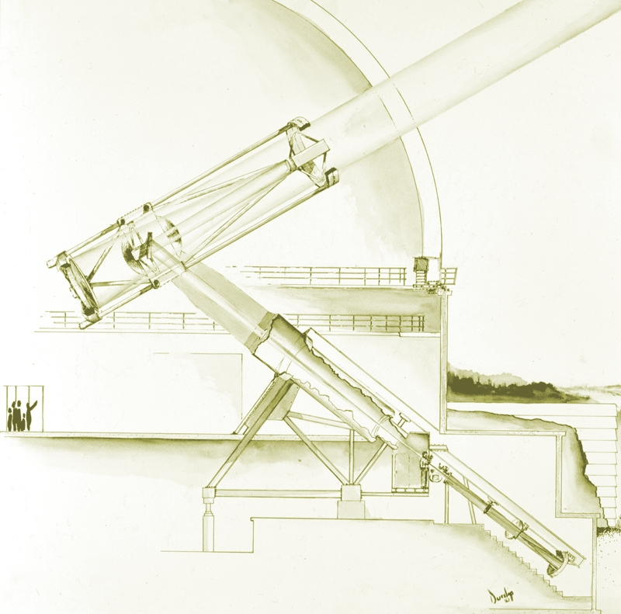

Telescope Maintenance
&
Operations Manual
2

